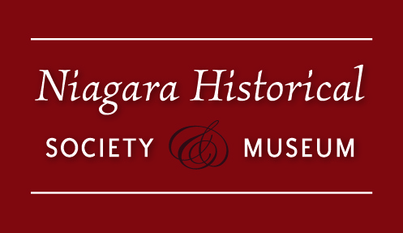

Niagara Historical Society
126th Annual General Meeting
Thursday, October 14, 2021, at 6 pm ON ZOOM
MINUTES

- Welcome and confirmation of a quorum (David Hemmings)
  - Present: 7 Directors, 4 Staff, 23 Members present
  - A quorum was present.
  - David welcomed everyone to the 126th Annual General Meeting of the Niagara Historical Society.
- Approval of the Minutes (David Hemmings)
MOTION: (Stewart Hall, Ted Rumble)
To approve the minutes of the Annual General Meeting of October 15, 2020.
Passed
- Governance Committee Report (Judy Thornton)
  - See reports circulated in advance.
  - No comments. Approved.

MOTION: (Mona Babin, Stewart Hall)
To accept changes to the Constitution as listed in the Notice to Members: Constitutional Change 2021.
Passed
- Finance and Administration Committee Report and 2021/2022 Budget presentation (Mona Babin)
  - Budget Presented.
  - No comments. Approved.
- Request to appoint audit firm (Mona Babin)
MOTION: (Adrienne Stevenson, Mona Babin)
To appoint Bridgman & Durksen as our auditors for the 2021 fiscal year.
Passed
- Membership and Operational Fundraising Committee Report (Mona Babin)
  - See Report.
  - No comments. Approved.
- Physical Plant and Planning Committee Report (Jim McArthur)
  - See Report
  - No questions.
- Publications & Communications Report (John Sayers)
  - See report
  - No comments, except below. Approved.
  - Ted Rumble congratulated the people who produced the publication “Making Her Mark” and recommended it to members.
- Managing Director's Report/Collections Report (Sarah Kaufman)
  - See report
  - No questions.
- Report from the Nominations Committee (Faith Bell)
MOTION: (Mona Babin, Jim McArthur)
To accept the nominees as new Directors to the Board. (George Webber, Alexander Topps, Tim Johnson, Ben Buholtz, Sandra Aversa, Stewart Hall).
Passed
MOTION: (Stewart Hall, Adrienne Stevenson)
To accept the nominees to the Executive Committee (Mona Babin, Ted Rumble, George Webber, Alexander Topps)
Passed
- Elections for the 2022 Nominations Committee (David Hemmings)
MOTION: (Ann Marie Lorenc, Mona Babin)
To accept the new slate for the 2022 Nominating Committee (David Hemmings, John Sayers, Lorraine Joyner).
Passed
- Planned Giving Committee Report (Mona Babin)
  - See Report
  - No comments. Approved.
- Capital Project – Planning & Logistics Committee (Alex Topps)
  - See report
  - No comments. Approved.
- Capital Fundraising Committee (Sarah Kaufman)
  - See report
  - No comments. Approved.
- Diversity & Inclusion Taskforce (George Webber)
  - See report
  - No questions
- President's Report (David Hemmings)
  - David thanked the staff. Our 125th Anniversary legacy project has been installed. The Museum is the cultural heritage centre of Niagara-on-the-Lake. He thanked those who served with him on the Board, as well as those who have contributed to the Expansion Fundraising Campaign. He thanked Allan Bisback for his support and advice. Best wishes to the new President Mona Babin and the incoming board.
  - On behalf of the staff and membership, Sarah thanked David for his six years of service on the Board, of which three years were as President.
- Adjourn
MOTION: (George Webber, Mona Babin)
To adjourn the meeting
Passed
Meeting was adjourned at 6:33 pm

Important Dates:

October 20: Virtual Lecture, 11 am
November 1-12: The NOTL Poppy Project
November 3: Virtual Lecture, 11 am
November 5: Doc Club, 10 am
November 11: We’ll Meet Again
November 17: Virtual Lecture, 11 am
December 1: Virtual Lecture, 11 am
December 3 & 4: Rotary Holiday House Tour
December 10: Doc Club, 10 am
December 15: Virtual Lecture, 11 am
December 18 – January 1: Museum Closed

